|  |  |
| --- | --- |
|  |  |

|  |
| --- |
| **Activity 6.2.5 Capacitors** |

Introduction

Capacitors are like batteries in that they can store electrical energy. Capacitors have an advantage over batteries in that they are charged more quickly, can be charged and discharged many times, and store energy more efficiently. Their disadvantage is that they cannot store a lot of energy. Could capacitors be the answer for electric vehicles? They will be the answer only if engineers can perfect what they call super capacitors. Super capacitors would have all of the advantages of capacitors, but they would also hold a charge much longer. Even current hybrid cars face the grim reality that their batteries will have to be replaced after about 100,000 miles. Cars powered by super capacitors, however, could last much longer, which would save car owners the expense of replacing multiple batteries. It would also lessen the environmental concerns of batteries disposal.

Equipment

* Internet access
* Capacitors presentation
* Schematic Symbols Chart
* Engineering notebook
* Electrolytic Capacitors, 10µF, 470µF and 4700 µF
* Snap Circuits® components
* Board, voltage source, and power supply
* 2 LEDs
* 2 Pushbutton switches
* Various sizes of snap wires

Procedure

In teams of two to three, you will charge and discharge capacitors to simulate a camera flash. Make notes and build the circuit as shown in the **Capacitors** presentation.

There are many kinds of capacitors, but they all do the same thing: __Store Electricity__. The simplest capacitor is two _Conductors_ separated by an _Insulating Material_ called the dielectric. The dielectric can be paper, plastic film, mica, glass, ceramic, air, or a vacuum. The conducting plates can be aluminum discs, aluminum foil, or a thin film of metal applied to opposite sides of a solid dielectric. The conductor-dielectric-conductor sandwich can be rolled into a cylinder or left flat.

Capacitors come in all shapes and sizes. Some are called electrolytic, and have _Positive_and _Negative_ legs which must be connected the right way in a circuit. However, usually those with a small value (less than 1 μF) can be connected any way in the circuit.

The ability to store electrons is known as _Capacitance_ and is measured in _Farads_. A 1-farad capacitor connected to a 1 volt supply will store 6,280,000,000,000,000,000 (6.28 x 1018) electrons! Most capacitors have much smaller values. Small capacitors are specified in _Picofarads_ (trillionths of a farad) and larger capacitors are measured in _Microfarads_ (millionths of a farad).

1 farad = 1 F

1 microfarad = 1 μF = 10-6F = 0.000 0001 F

1 picofarad = 1 pF = 10-12F = 0.000 000 000 001 F

In our labs, we will be using microfarad (μF) capacitors.

It is very dangerous to touch the inside of electrical equipment which uses capacitors. In televisions, for example they are used to build up and store the high voltages needed to make it work, and the capacitors remain highly charged even after the appliance has been unplugged.

Charging Circuit Schematic Drawing

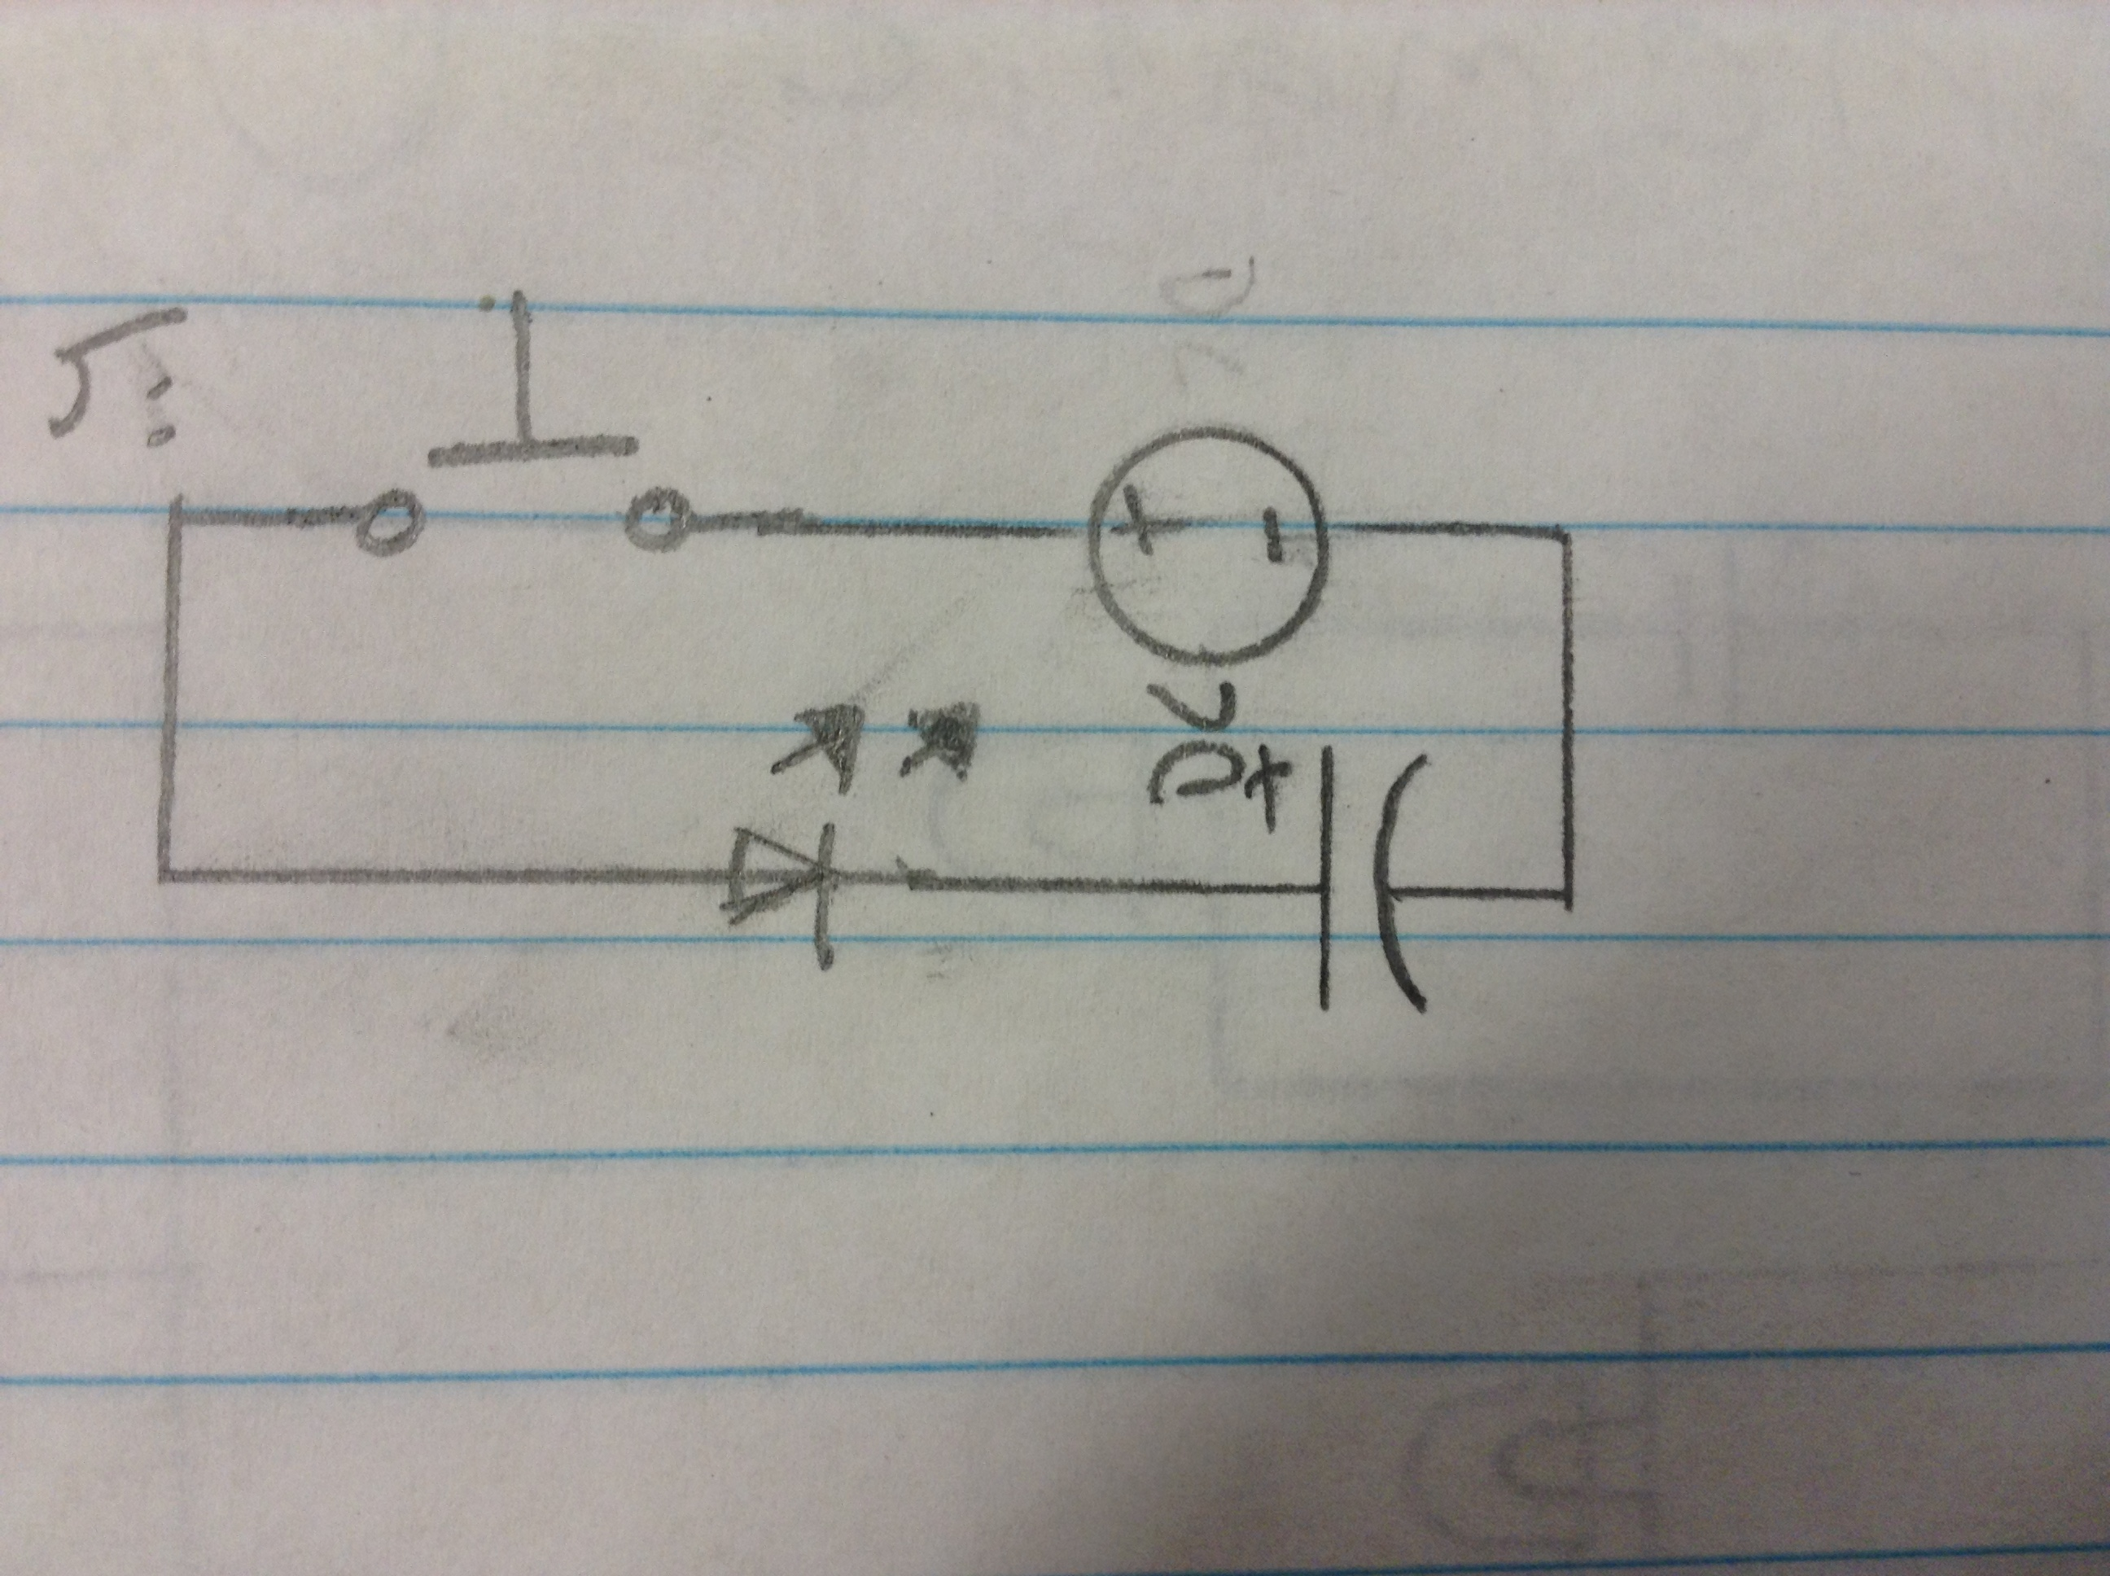

Discharging Circuit Schematic Drawing

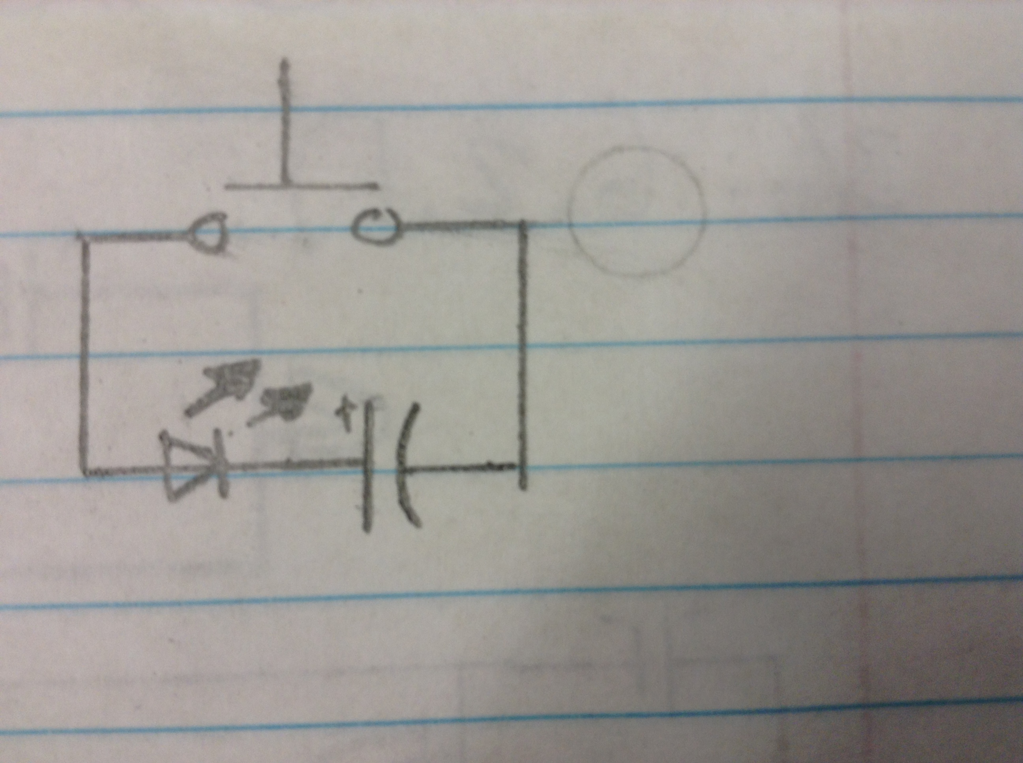

Answer the following questions as you complete the lab.

1. In “Charging the Capacitor” what did the LED do after the capacitor was plugged in?

The LED turned on.

1. In “Discharging the Capacitor” did the polarity of the capacitor affect the circuit? Explain.

No, the LED turned on when the capacitor was plugged in both directions.

1. In “Discharging the Capacitor” what did the LED do after plugging in the capacitor and pushing the button? Explain.

The LED turned on because there were electrons stored in the capacitor which began to flowm, when the button completed the circuit.

1. Compare the length of time the LED stayed on for each of the three capacitors. Explain what happened.

The smallest capacitor took the shortest amount of time to charge and lasted the least amount of time to run out of charge. The large capacitor took the longest to charge, about 2 seconds, and lasted the longest when in the discharge circuit. The medium sized capacitor lasted not as long as the large capacitor, but longer than the small one.

Instructor Verification of Capacitor Circuits ___________________

Conclusion

1. Describe something other than the examples you’ve been given that you believe uses a capacitor and its function in the device.

A radio uses capacitors to send out a specific frequency by having a capacitor charge and discharge into a coil of wire. The size and timing of the capacitor determines the frequency and is amplified by a radio station.

1. What do capacitors have to do with the dangers of older television sets?

Older TV sets have capacitors that are not are as advanced as today and discharge less often. Since they do not discharge as much, they can collect lots of electricity and can discharge in lethal amounts.